Instruction

DDZY1218 Single Phase Prepayment Meter

Sneda Smart Meter Limited

Brief of products
1. General
This is an advanced smart meter in the world. It is adopt large scale integrated circuit board and SMT technology to produce. It is tailored to ECG specification and mimic ECG’s tariff.
1.1 Features
窗体底端
- It is W-embedded high-speed and precision A/C V/A acquisition module with high accuracy, accurate and real-time measurement;
窗体顶端
- It measures active and reactive power, stores the data. It communicate with RS485 and infrared;
It hasIII窗体底端
窗体顶端
- It has an excellent compatibility of electromagnetic, is able to withstand the interference of high voltage spikes, strong magnetic fields, strong static electricity and lightning surges, and has a strong range of temperature adaptability;
窗体底端
窗体顶端
- It has three-phase power supply interdependently and works properly even any a single phase on;
iI窗体底端
窗体顶端
- It Built-in backup battery power, the clock will work 10 years without outside power supply;
1.2 Specification
Power Supply: AC 230V
Current: 5(30), 5(60) Amps
Accuracy: 1.0
Operating Temperature: –40 ~ +70 ºC
Relative Humidity: <=98% non-condensing
Frequency: 50Hz±5%

2. LCD display

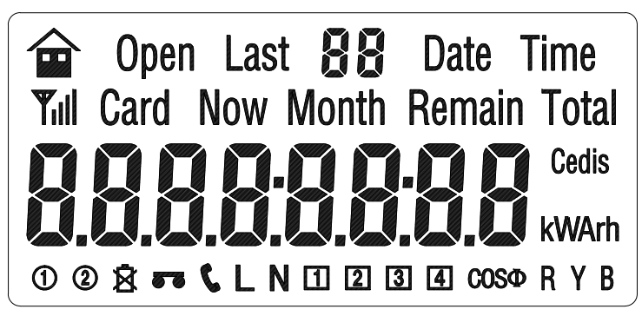

Symbol | Indication
kW h | kWh—Active power kW—Active demand
kV Arh | kvarh—Reactive power kvar—Reactive demand
VA | V—Voltage A—Current
COSΦ | Power factor
Cedis | Money
 | RS-485
 | Battery statue
 | Permission to program
 | GPRS
 | In factory mode
 | Currently tariff table applied
 | Phase A, B, C
 | Currently block of tariff applied, if more than 4 will be 1 + 4=5，2 + 4=6，3 + 4=7，1 + 3 + 4=8，2 + 3 + 4=9
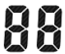 | Serious No.
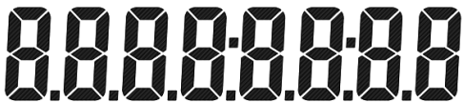 | Figure

3. Installation and wiring
3.1 Meter should be installed at a safe, clean, air pass and dry place. It is will be in the meter enclosure. The height of meter should not allow the children to reach.
3.2 There is a hole on the upper side of meter for fixing screw to pass and hang the meter. There are two holes down for screw to fix the meter.

Front and Side view:
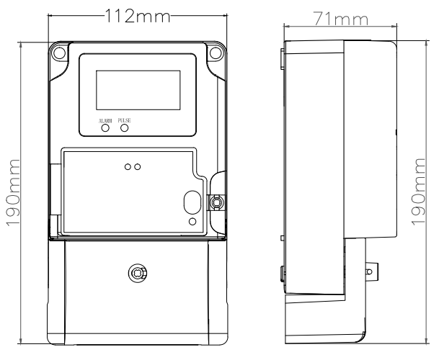
Side and back view：
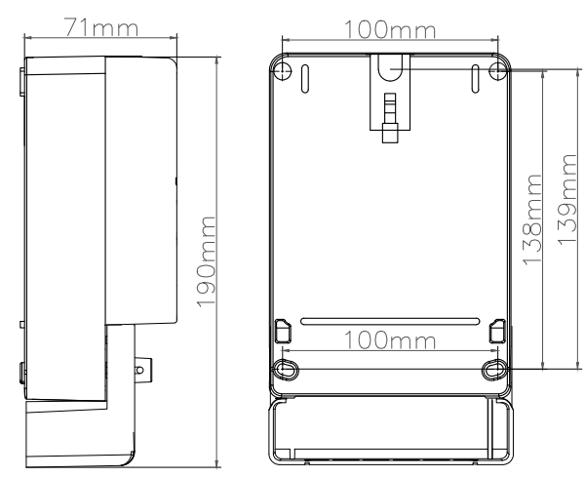

3.3 Connection
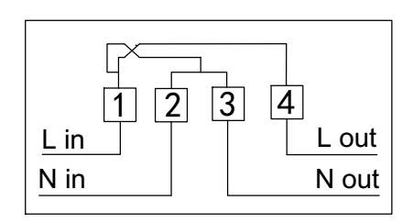

4. Working principal
It is formed with measuring unit and processing unit to measure and compete the power consumption. It can display the information of meter, store and output the data.
Diagram 1：

A/C V/A
Module

CPU
LCD
I
Memory
GPRS
Pulse
PC
RS-485
V
Lap top
Infrared
Hand Set
Warning
Power supply
Power
management
Battery

When meter works, the module takes the samples voltage and current from loop to compete and process, then send to CPU for smart control. The processed data will be stored in the memory and be sending out by LCD and by interface of RS 485, GPRS and infrared.

5. Auto scroll display mode and button display mode

Auto scroll display mode. Every display will be in screen for 5 min., and then scroll to next.
It is can be in button display as well. Press the button on the meter, it will enter button display mode, you can get the what you want to see. Press button Up or Down, it will scroll the figure. If it is idle for 20 sec., the display will change to auto scroll display mode again.

 | Information
S No | Indication | Code | Button display | Auto display | Power off | Technician
1 | Error |  | ● | ●
2 | Date | 13 + Now + Date | ● | ● | ●
3 | Time | 14 + Now + Time | ● | ● | ●
4 | Lower 8 digit of meter No. | 15 | ● |  | ●
5 | Higher 4 digit of meter No. | 16 | ● |  | ●
6 | Lower 8 digit of customer ID | 17 | ●
7 | Higher 4 digit of customer ID | 18 | ●
8 | Money left | 19 + Now + Remain + Cedis | ● | ● | ●
9 | Current consumption in kWh | 20 + Now + Month + kWh | ● | ● | ●
10 | Current charge in Cedis | 21 + Now + Month + Cedis | ● | ●
11 | Accumulate consumption in kWh | 22 + Now + Total + kWh | ● |  | ●
12 | Accumulate charges in Cedis | 23 + Now + Total + Cedis | ●
13 | Voltage | 24 + Now + V | ●
14 | Current | 25 + Now + L + A | ●
15 | A,B,C Power | 27 + Now + kW | ●
16 | Maximum demand happened date | 28 + Date | ●
17 | Maximum demand happened time | 29 + Time | ●
18 | Maximum demand value | 30 + kW | ●
19 | Consumption of last day | 31 + Last + kWh | ●
20 | Charge of last day | 32 + Last + Cedis | ●
21 | Days left for use | 33 + Remain | ●
22 | Over voltage limit set | 34 + V |  |  |  | ●
23 | Over current limit set | 35 + A |  |  |  | ●
24 | Over lord limit set | 36 + kW |  |  |  | ●
25 | Display warning | 37 + Cedis |  |  |  | ●
26 | Cut off warning | 38 + Cedis |  |  |  | ●
27 | Version No. | 39 |  |  |  | ●
28 | Counter of temper meter | 40 |  |  |  | ●
29 | Counter of cut off | 41 |  |  |  | ●
30 | Counter of illegal card | 42 |  |  |  | ●
31 | Counter of power supply off | 43 |  |  |  | ●
32 | Over consumption | 44 + Cedis |  |  |  | ●
33 | Consumption of last month | Last + 01 + Month + kWh | ● | ●
34 | Charge of last month | Last + 01 + Month + Cedis | ● | ●
35 | Consumption of last 2nd month | Last + 02 + Month + kWh | ●
36 | Charge of last 2nd month | Last + 02 + Month + Cedis | ●
37 | Consumption of last 3rd month | Last + 03 + Month + kWh | ●
38 | Charge of last 3rd month | Last + 03 + Month + Cedis | ●
39 | Consumption of last 4th month | Last + 04 + Month + kWh | ●
40 | Charge of last 4th month | Last + 04 + Month + Cedis | ●
41 | Consumption of last 5th month | Last + 05 + Month + kWh | ●
42 | Charge of last 5th month | Last + 05 + Month + Cedis | ●
43 | Consumption of last 6th month | Last + 06 + Month + kWh | ●
44 | Charge of last 6th month | Last + 06 + Month + Cedis | ●
45 | Consumption of last 7th month | Last + 07 + Month + kWh | ●
46 | Charge of last 7th month | Last + 07 + Month + Cedis | ●
47 | Consumption of last 8th month | Last + 08 + Month + kWh | ●
48 | Charge of last 8th month | Last + 08 + Month + Cedis | ●
49 | Consumption of last 9th month | Last + 09 + Month + kWh | ●
50 | Charge of last 9th month | Last + 09 + Month + Cedis | ●
51 | Consumption of last 10th month | Last + 10 + Month + kWh | ●
52 | Charge of last 10th month | Last + 10 + Month + Cedis | ●
53 | Consumption of last 11th month | Last + 11 + Month + kWh | ●
54 | Charge of last 11th month | Last + 11 + Month + Cedis | ●
55 | Consumption of last 12th month | Last + 12 + Month + kWh | ●
56 | Charge of last 12th month | Last + 12 + Month + Cedis | ●

5.1 Records of power supply off
It is recorded as power supply off only if when all the three phases of A.B.C. are off. It keeps last ten events of power supply off and on. Records includes the time of power supply off and time of power supply on.

5.2 Warning display
When following faults happens, faulty code will remain in the screen for 10 min., and then the background light goes off and waits for technician form ECG to come and handle.（此处应该列出几项具体的报警情况）
5.3 Programming
Permission to program: Open the GPRS cover by an authorized person and press the programming button, the sign of will show on the screen, meter is ready to program.
Forbidden to program: Press the same button again and sign will go off. It is forbidden to program of the meter.
Address of communication: Address has to be entered before any equipment communication to the meter. It is only ID to commute to meter with any equipment.
5.6 RS-485 and GPRS communication
Apart from RS-485 interface to commute with meter, other options like GPRS or infrared are also provided to do so. The baud rate for GPRS and RS485 is 2400bps and for infrared is 1200bps.
5.7 Event clear function
There are tow clear functions, one is over all clearance and one is single event clearance. Single event clearance can be used for clear records of Power-off , records of Programming, records of Temper meter. Some records can be only cleared in statues of production jointly by permission to program such as records of Event clearance, records of Meter reset and records of Consumption.

5.4 Anti-temper of meter
Bit8 | Bit6 | Bit5 | Bit4 | Bit2 | Bit1 | Bit0
Magnetic field  0 No  1 Yes | Current is 0 in live line 0 No  1 Yes | Unbalance of current  0 No  1 Yes | Phase line lost  0 No  1 Yes | Current reverse  0 No  1 Yes | Open top cover  0 No  1 Yes | Open wire cover  0 No  1 Yes

When Bit0，Bit1，Bit8is is Yes, the meter will cut off the power supply to the customer to prevent further damage to the meter and been recorded. Other Bits Yes, only been recorded but not cut off.

5.5 Other features

1-50 records of purchase include date, purchase amount, money left before purchase, amount after top up and totally purchase times.

Last 2 records of cut off by meter (Code + time of cut off + time of resume power supply by top up)

1-100 records of temper of meter.

1-100 records of illegal cards ( Time + type of cards + serious No.)

1-100 records of power supply off (time of started + time of resumed)
- 100 days in every 15 min. Load profile

6. Transportation and storage
窗体顶端
- Products in the transport and unpacking should not be violent impact, and in accordance with GB / T15464-1995 "General Instrument Packaging technical" provisions of transport and storage
窗体底端
窗体顶端
- Stock and storage should be stored in the original packaging conditions, the stack height should not exceed 5 layers
窗体顶端
- Storage should be clean, the ambient temperature should be 0 ~ 40 ℃, relative humidity less than 85%, and in the air does not contain enough to cause corrosion of harmful substances.

